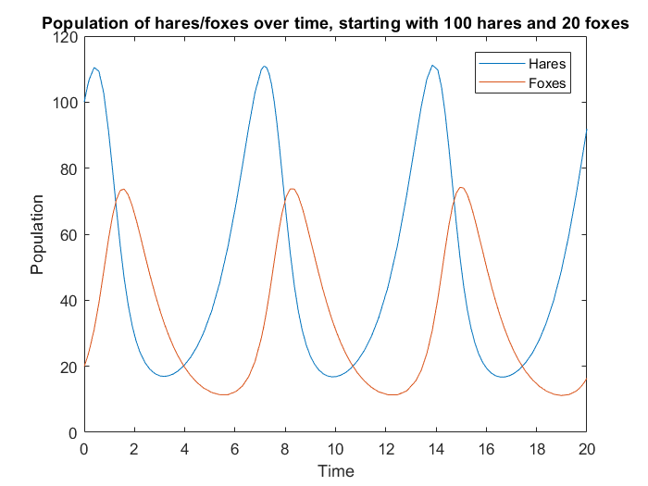

Figure 1: Graph of the evolution predator and prey population over time. The blue line corresponds to the population of hares, the brown to that of foxes. The most striking feature is its cyclical nature. Never will the population of predators or prey ever fall below a number, and likewise never will they go above a limit. This could be due to the lagging feature of predators seen in this graph. As the population of prey increases, the population of predators increases too, and acts as a check on the population of prey. But as the population of prey decreases, the population of predators decreases too, but lags the population of prey. This lagging feature allows the populations of both to stabilise before increasing again, and thus gives rise to the cyclical nature of the population growth.

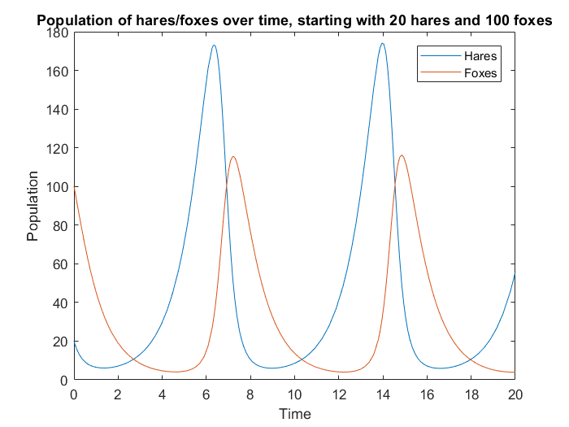

Figure 2: Graph of the evolution of population against time. The blue line corresponds to the population of hares, the brown to that of foxes. This time, the initial number of prey is much lower than the initial number of predators and it could be expected that the population of prey goes to zero. However, a cyclical nature still arises. The number of prey never quite goes to zero, but instead decreases the population of predators at a much faster rate, to such a low number that the population of prey can grow at an appreciable rate, to a much higher number than its initial population size. It turns out that the extreme numbers change only the extent of the growth rate, whose lagging nature still allows for the cyclical growth.

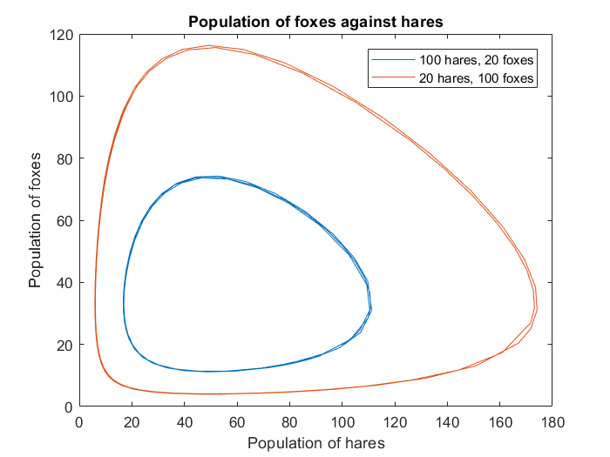

Figure 3: Graph of population of predators against that of prey for two different initial conditions. The one in blue, for 100 hares and 20 foxes, in brown, for 20 hares and 100 foxes. It shows clearly, the cyclical nature of the predator/prey population system, that even in extreme conditions (low prey, high predators, or high prey, low predators), the system is still cyclical. The only change that occurs is the extent of the population change.

Listing of the function file, Volterra.m

% volterra.m

function dy = volterra(t,y)

% Initial parameters

a = 1;

b = 0.03;

c = 1;

d = 0.02;

dy = zeros(2,1);

dy(1) = a.\*y(1) -b.\*y(1).\*y(2);

dy(2) = -c.\*y(2) + d .\* y(1).\*y(2);

end

Listing of the graph creator, solve.m

% solve.m

% Solves the volterra differential equations to obtain the population of

% hares and foxes over time.

hares = 100;

foxes = 20;

[T,Y] = ode45(@volterra,[0 20],[hares foxes]);

plot(T,Y(:,1)); % Plot population of hares

hold on

plot(T,Y(:,2)); % Plot population of foxes

title("Population of hares/foxes over time, starting with " + hares + " hares and " + foxes + " foxes");

xlabel("Time");ylabel("Population");legend("Hares","Foxes");

figure

plot(Y(:,1) , Y(:,2)); % Plot pop of foxes against hares

hold on

hares = 20;

foxes = 100;

[T,Y] = ode45(@volterra,[0 20],[hares foxes]);

plot(Y(:,1) , Y(:,2)); % Plot pop of foxes against hares

title("Population of foxes against hares");

xlabel("Population of hares");ylabel("Population of foxes"); legend("100 hares, 20 foxes","20 hares, 100 foxes");